2018 ASEAN SMART CITIES FRAMEWORK
Endorsed in Singapore on 8 July 2018

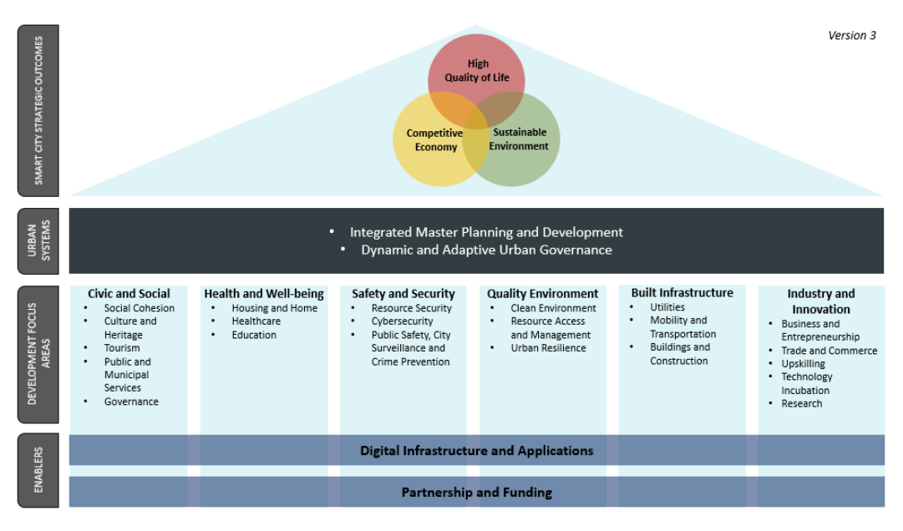

- Most of ASEAN’s growth has been, and will continue to be, driven by urban centres, with 90 million more people expected to urbanise by 2030 and “middleweight” cities of between 200,000 and 2 million residents forecast to drive 40% of the region’s growth. This rapid urbanisation is not without its challenges, as it has implications for important issues such as city congestion, water/air quality, poverty, rising inequalities, the urban-rural divide, as well as people’s security and safety. Technological and digital solutions as well as innovative non-technological means can be utilised to resolve these issues and to enhance the quality and accessibility of services, thereby improving our people’s lives across the urban-rural continuum, creating new opportunities for them and ensuring that no one is left behind.

- In this connection, ASEAN Member States (AMS) have established an ASEAN Smart Cities Network (ASCN). The ASCN is a collaborative platform where cities work together towards the common goal of smart and sustainable urban development. Its primary goal will be to improve the lives of ASEAN’s peoples, and promote new business opportunities and innovation in smart city development, using all means including technology. The ASCN will adopt an inclusive approach to smart city development that is respectful of human rights and fundamental freedoms as inscribed in the ASEAN Charter. It will focus on people-oriented, people-centred solutions and liveability, and also contribute to enhancing mutual understanding across cultures. Ultimately, the ASCN will contribute to realising a “politically cohesive, economically integrated, and socially responsible” Community in line with the ASEAN Community Vision 2025, contribute to relevant aspects of the ASEAN Community Blueprints 2025, the Master Plan on ASEAN Connectivity (MPAC) 2025 and the Initiative for ASEAN Integration (IAI) Work Plan III, and build on the global commitment to achieving the 2030 Agenda for Sustainable Development and the New Urban Agenda.

- The ASEAN Smart Cities Framework serves as a non-binding guide to facilitate smart city development in each ASCN city, in a manner that is specific to each city’s needs and potentials, as well as its local and cultural context. This document articulates the key features of ASEAN’s smart cities, by i) identifying strategic outcomes; and ii) outlining key urban systems, focus areas, and enablers. This Framework seeks to complement existing national development plans or help to build new ones.

Strategic Outcomes

- A smart city in ASEAN harnesses technological and digital solutions as well as innovative non-technological means to address urban challenges, continuously improving people’s lives and creating new opportunities. A smart city is also equivalent to a “smart sustainable city”, promoting economic and social development alongside environmental protection through effective mechanisms to meet the current and future challenges of its people, while leaving no one behind. As a city’s nature remains an important foundation of its economic development and competitive advantage, smart city development should also be designed in accordance with its natural characteristics and potentials.

- At a strategic level, a smart city in ASEAN should achieve a balance between three interdependent objectives.

- Competitive Economy. A competitive economy in a smart city provides opportunities for all people, including those in rural areas, to make a living and achieve a degree of economic security, ensuring that no one is left behind. It also helps to promote start-up accelerator and incubator networks to support entrepreneurship among its people, especially its youth. It is able to generate income, create job opportunities and attract investment to sustain itself — especially for small and medium enterprises (SMEs) and innovation startups — promoting equitable regional economic growth across the urban-rural continuum. It will also focus on the development of the digital and creative economies, leveraging upon innovation and entrepreneurship to generate business opportunities. Collectively, this means an improvement in the region’s capacity to respond to global challenges and mega trends, taking into account the different levels of development in each city.

- Sustainable Environment. A sustainable environment is essential to ensure the long-term viability and accessibility of healthy ecosystems, including vital resources such as land and water, as well as to enhance disaster resilience and mitigate climate change impact. It is also an integral determinant of the region’s growth. Hence, a smart city could incorporate a sustainable, green and resilient growth agenda that promotes the science-based use of, and support for, green technology and energy, as well as promote sustainable consumption and production through innovative policies.

- High Quality of Life. High quality of life focuses on the social, physical and psychological well-being of people across the spectrum of society, including the vulnerable groups. A smart city should promote equitable access to quality goods and services; social infrastructure such as education, healthcare and housing; safety and security; preservation of culture; and any other resources and opportunities needed to lead a fulfilling and meaningful life. This will create a more equitable, inclusive and resilient society.

Urban Systems

- To achieve the three strategic outcomes of an ASEAN smart city, two key urban systems should be focused upon to manage, balance and coordinate the various domains and priorities of a city.

- Integrated Master Planning and Development enables the government to create and manage the various urban domains that balance the three strategic outcomes of smart city development, and ensures that smart urbanisation aligns with policy and regulatory frameworks. Amidst a dynamic political, economic and social environment, the drawing up of long-term plans and blueprints allows cities to meet their needs in a sustainable manner. Master planning and the implementation of plans should also be integrated into the planning process. The implicit principles of this system include: adopting a long-term perspective; productive decision-making; built-in flexibility; effective execution and implementation; systematic innovation; as well as robust monitoring and evaluation.

- Dynamic and Adaptive Urban Governance is the foundation of effective public leadership. It is about engaging diverse and capable stakeholders such as citizens, government officials and businesses, including local enterprises and startups, in decision-making and oversight of how the city plans, utilises and manages its resources. Various collaboration modalities can be explored, such as public-private partnerships (PPP), with government support for development efforts. The principles under this system include: visionary and pragmatic leadership; integrity; sound institutions and rule of law; stakeholder involvement; and market-oriented implementation.

Focus Areas

- The detailed conceptualisation and implementation of smart city projects in ASEAN can involve one or more of the focus areas below, which reflect the cities’ and people’s needs.

- Civic and Social. Smart cities in ASEAN can focus on enhancing social harmony, cultural diversity and the spirit of community. Smart solutions can advance goals such as (i) achieving social cohesion amidst diversity; (ii) promoting social equity to eliminate all forms of discrimination; (iii) preserving and deepening appreciation for cities’ cultural authenticity and heritage; and (iv) promoting the tourism sector. Smart cities can also leverage technology to improve the citizen experience and facilitate seamless living. They can find innovative and effective ways to enhance the delivery of public and municipal services, and work towards goals such as building a cashless society. Through good governance, they will ensure their capabilities in the provision of better service delivery, decision making, transparencies and accountability and information accessibility.

- Health and Well-being. Smart cities in ASEAN can apply innovative solutions to enhance the overall welfare of their citizens. This will improve the quality and efficiency with which they provide key services such as healthcare, housing and education, in a manner that optimises the use of public resources and enhances preparedness. It will also help to promote inclusive communities, and address barriers to the enjoyment of equitable access to opportunities for all ASEAN peoples.

- Safety and Security. Smart cities in ASEAN can adopt effective technologies to solve urban security problems, strengthening (i) security of vital resources such as food and water; (ii) cybersecurity of networked infrastructure and objects, as well as (iii) public safety, city surveillance and crime prevention, among others.

- Quality Environment. Smart cities in ASEAN can focus on building a quality environment, leveraging technologies to, for example, (i) maintain a clean and pleasant environment; (ii) promote the sustainable use of ecosystems, natural resources and biodiversity; and (iii) strengthen resilience against disaster risks and potential climate change impact.

- Built Infrastructure. Smart cities in ASEAN can invest in smart infrastructure to deliver multiple benefits across various stakeholders, whether private, public or corporate. These can include: (i) smart utilities such as energy, water and waste water treatment; (ii) smart mobility and transportation; and (iii) smart buildings and construction.

- Industry & Innovation. Smart cities in ASEAN can encourage their industries and businesses to capitalise on new technologies, using innovation as a catalyst to build competitive advantages and transform processes. This will increase their competitiveness and productivity, particularly for Micro, Small & Medium Enterprises (MSMEs), and promote inclusive and equitable growth. Initiatives in this area will focus on areas such as: (i) business and entrepreneurship; (ii) trade and commerce; (iii) upskilling of the workforce; (iv) technology incubation; and (v) research.

Enablers

- The planning, implementation and management of ASEAN smart cities and their detailed projects in the various focus areas can be supported by a few key enablers.

- Technological and Digital Solutions. Smart cities should embrace the opportunities afforded by new technologies and innovation, and adopt solutions with wide-ranging applications in order to maximise benefit optimisation and resource efficiency. Some examples include: (i) geospatial databases to monitor various aspects in the city; (ii) urban spatial data information systems; (iii) data analytics to support city operations and drive innovation; (iv) ICT networks; (v) automation; and (vi) e-payments and digital platforms.

- Partnership and Funding. Mutually beneficial partnerships, such as between ASEAN and its external partners, with other city networks, or with the private sector, will provide additional resources to support the development of smart cities in ASEAN. The development of ASEAN smart cities will be an iterative journey involving multiple stakeholders and robust financial investment, as well as the development of knowledge sharing and capacity strengthening platforms.

. . . . .

